**Discrete Mathematics Assignment 2 Question Bank**

1. Use Mathematical Induction to prove

(a). 1+5+9+…+(4n-3) = n(2n-1)

(b). 2+5+8+…+(3n-1)=n(3n+1)/2

2. Find the complete solution of the recurrence relation

an+ 2 an-1 = n+3 for n>=1 and with a0=3

3. Draw the Hasse diagram of

A=D36

B={1,3,5,15,30}

C={1,2,3,5,6,10.15.30}

4. Test whether following function is one to one, onto or not? f: Z -> Z, f(x) = x2+x+1

5. Let the functions f,g and h defined as follows

If f:R -> R is defined as f(x) = 2x+3

g: R -> R is defined as g(x) = 3x+4

h: R -> R is defined as h(x)= 4

Find i) hogof ii) go(hof)

6. For x, y € Z xRy if and only if 2x+5 is divisible by 7. Is R an equivalence relation ?

7. Find the Euler path,eulerian circuit ,Hamiltonian path, Hamiltonian Circuit if any from the following graph.

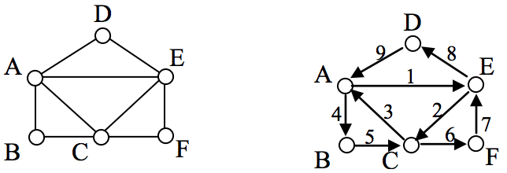

**c**

**d**

**b**

**e**

**a**

(a) (b)

8. Check following graphs are isomorphic or not, Justify your answer.

(a) refer first 2 graphs

(b) refer last 2 graphs

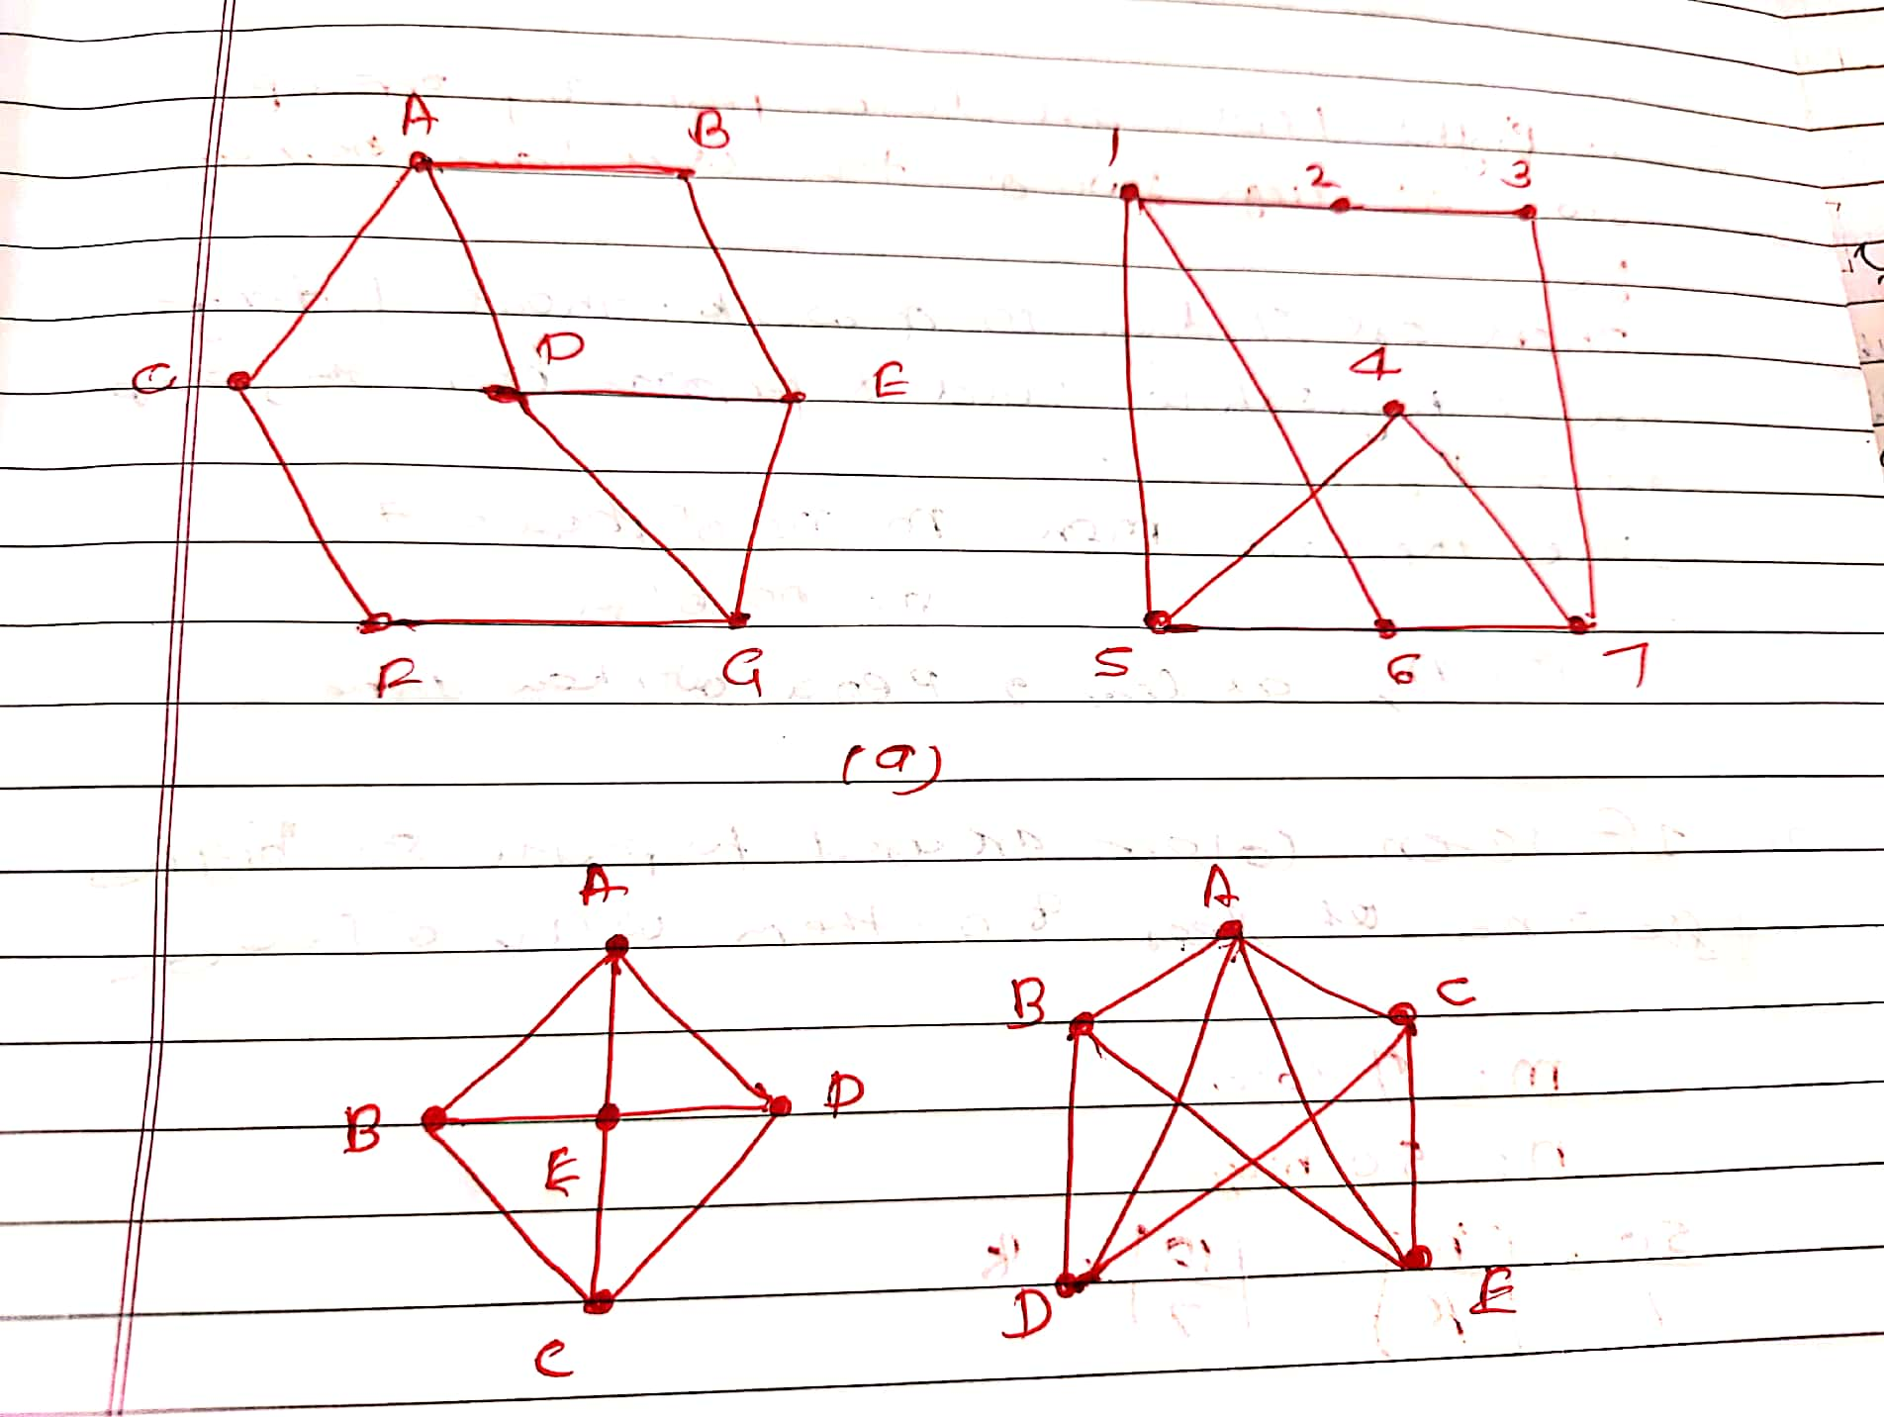

9. Define Lattice. Check if the following diagram is Lattice or not?

**e**

**c**

**d**

**b**

**a**

10. Define Extended Pigeonhole Principle. How many friends must you have to guarantee that at least five of them have their birthday in the same month.

11. If 14 numbers selected from set A={1,2,3,...,26}, then show that at least one of them is multiple of another

12. Define Distributive Lattice. Check if following diagram is distributive lattice or not?

**ec**

**c**

**d**

**a**

**b**